Instructions to use Zoom

Instructions for incoming calls

1. The family member needs to download Zoom from the play store or ITunes store and call the service to ensure there is not an existing call in progress.

2. Open the app

3. Join a meeting. You do not need to sign up or sign in
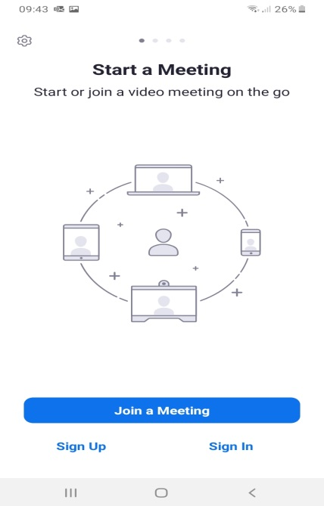

4. Add the services meeting ID and ensure the settings are the same as the illustration below. After the number has been entered press join meeting and then join with video.
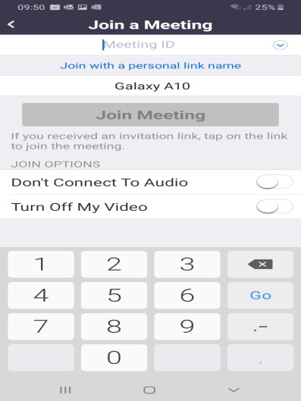
5. Once connected check the call via device audio has been allowed at the bottom left of the screen (this will turn green when connected)

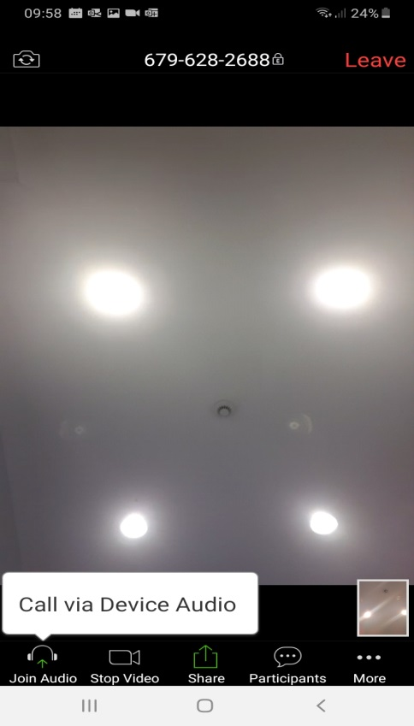

6. Leave the meeting when the call has finished.

